INSTALLING VM WARE AND INSTALLING VIRTUAL MACHINES
- You need these four files to install and configure your VM WARE
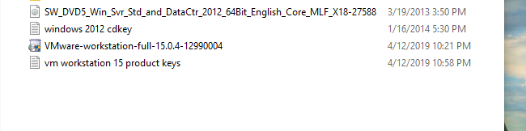

- Right click on Vmware-workstation and run as administrator
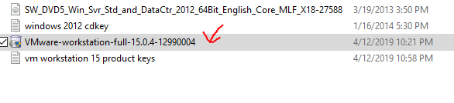

- Next click YES
- This should appear
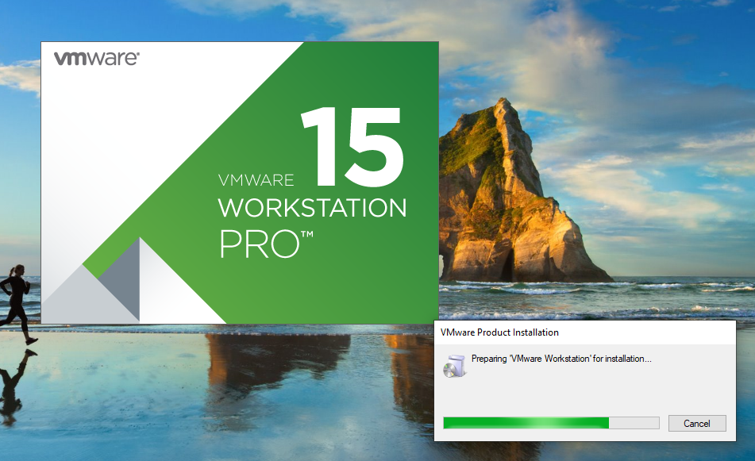

- Now select NEXT
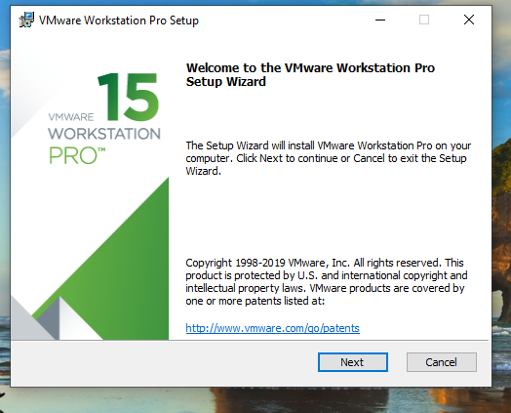

- Then select I accept and click NEXT
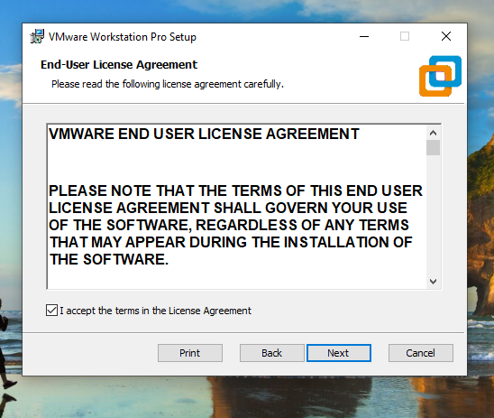

- Leave enhance keyboard unchecked and click NEXT
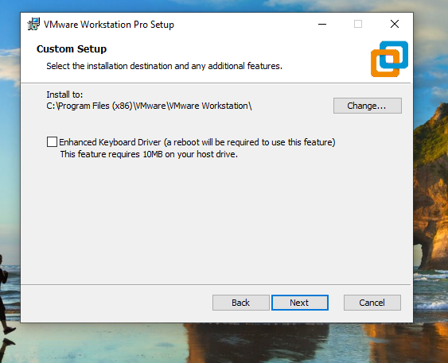

- Now Uncheck (check for updates …) and (Join the VM ware ….) and click NEXT
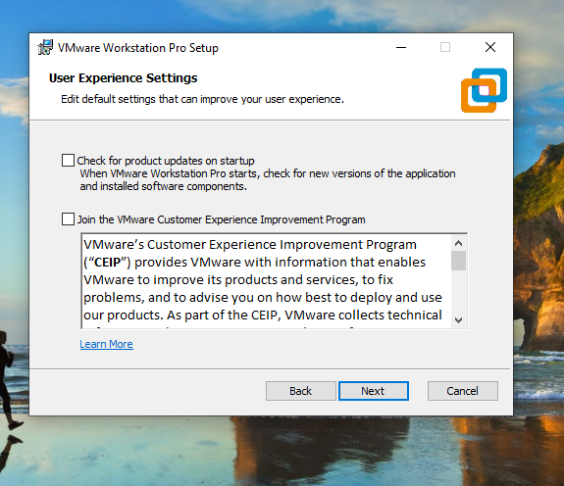

- Click NEXT and INSTALL
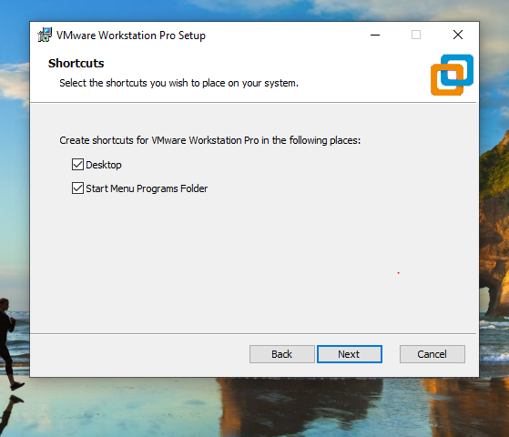
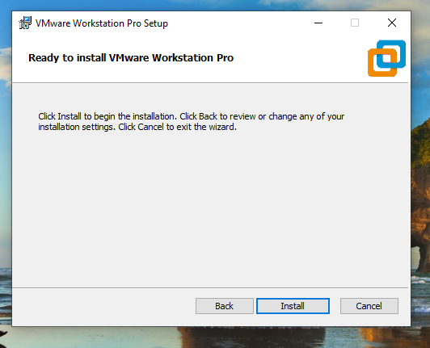

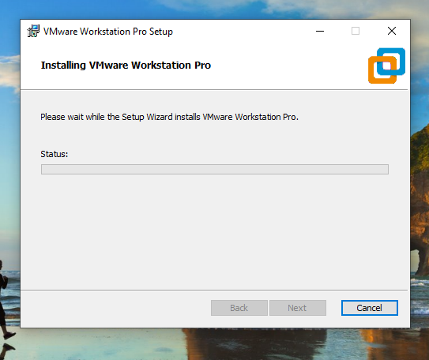
- After the installation is complete Enter Product key, randomly pick a key
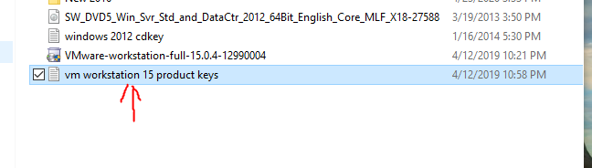
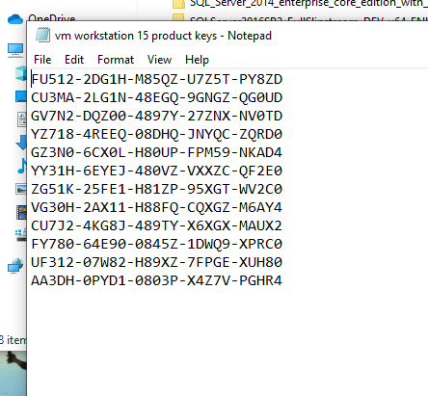
- After installation completes click LICENSE and insert randomly selected license key and click ENTER and FINISH
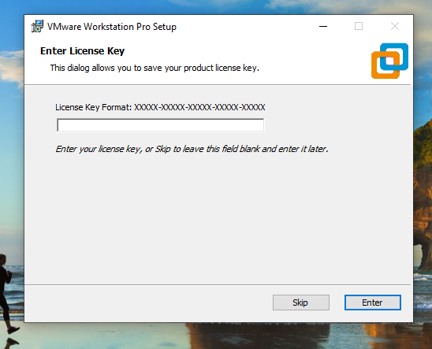
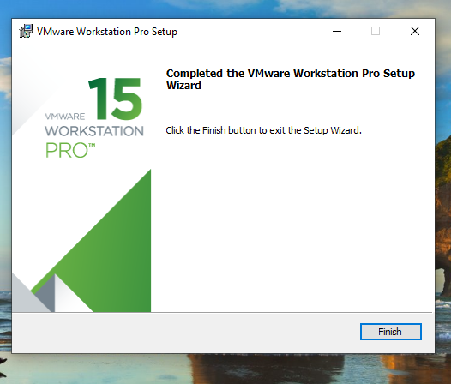

- Next launch VM workstation
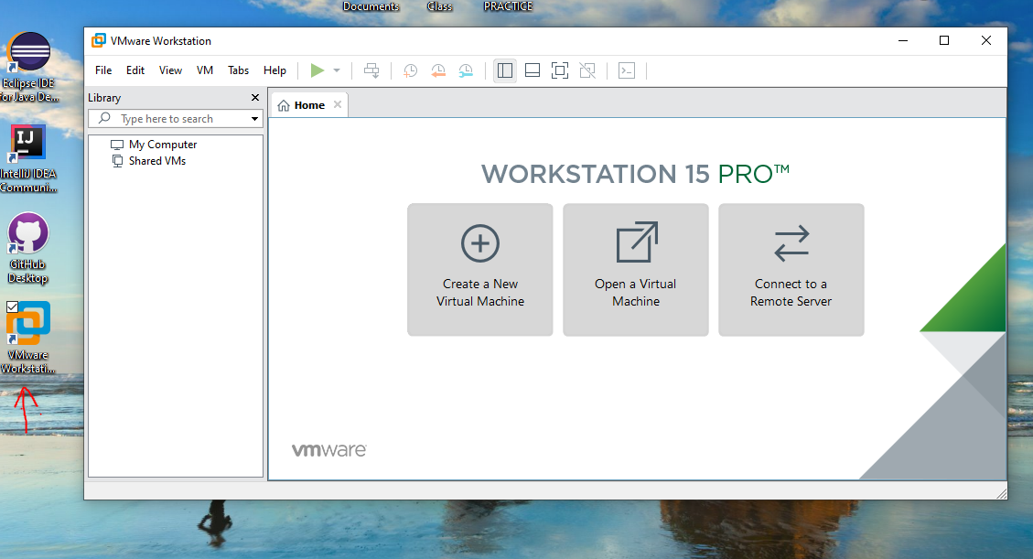

- Click create a new virtual machine to create a new virtual machine
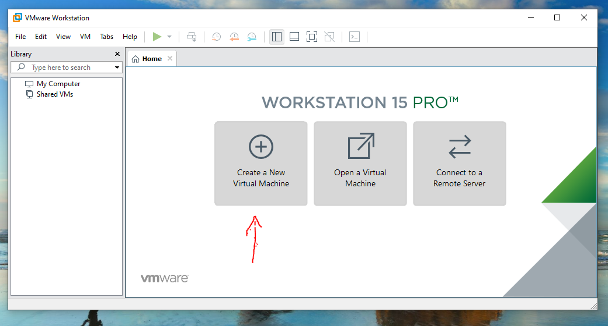

- Click NEXT
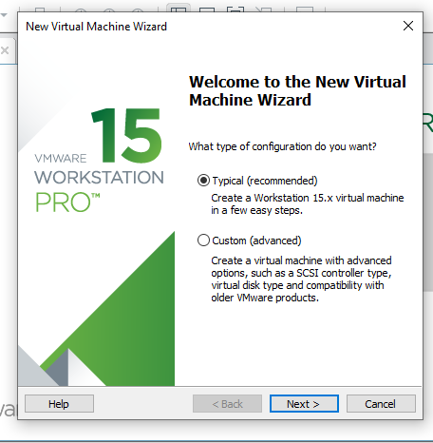

- Select Installer disc image file (ISO), click browse and navigate to the right ISO file and click it
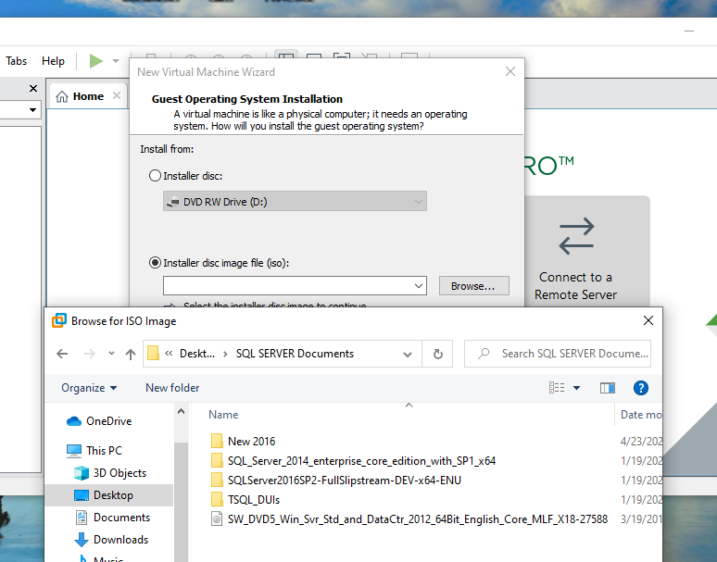
- After selecting the right ISO file click NEXT
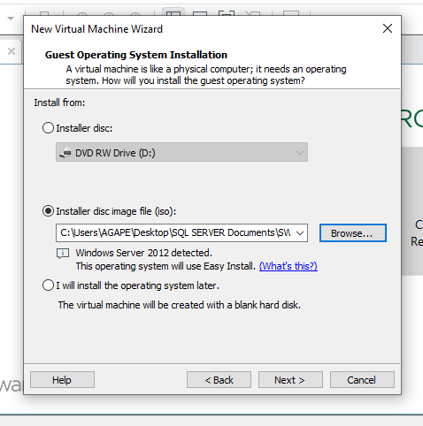

- The windows product key is inside the file labeled windows 2012 cdkey
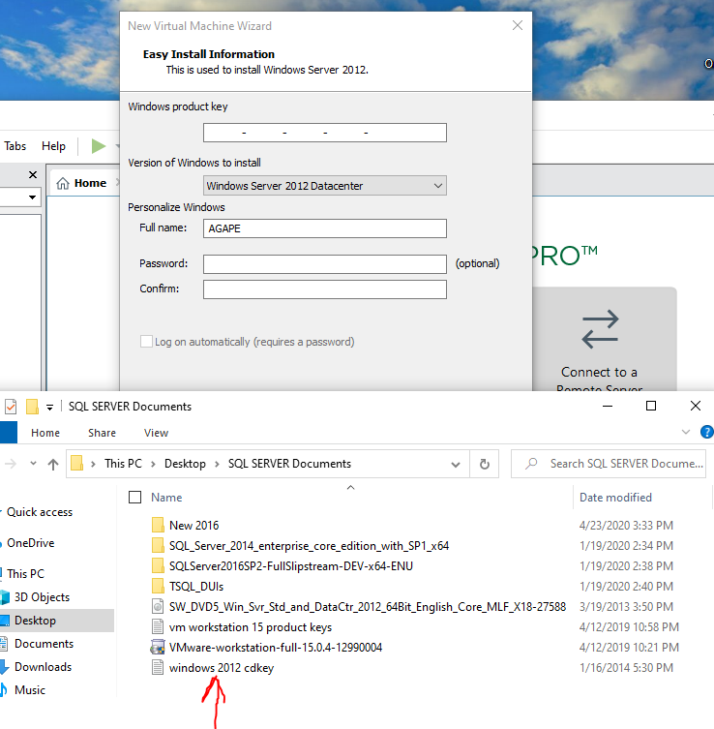

- Select the data center key, insert your password, and click next
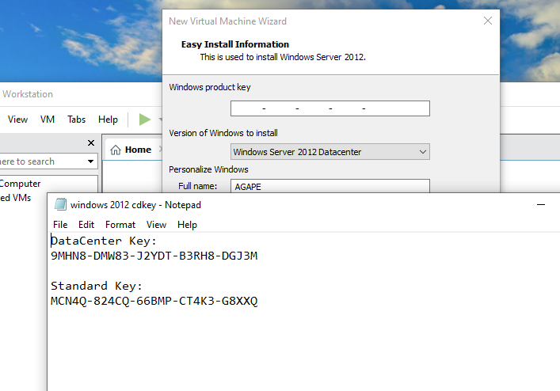
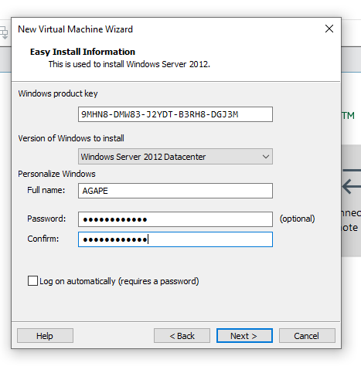
- Name your virtual machine and specify it’s path
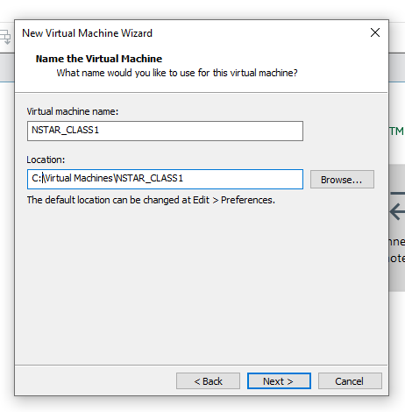

- Specify disk size
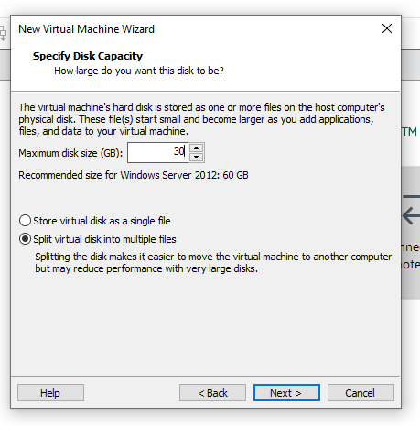
- Next click customize hardware and leave power on the virtual machine … checked
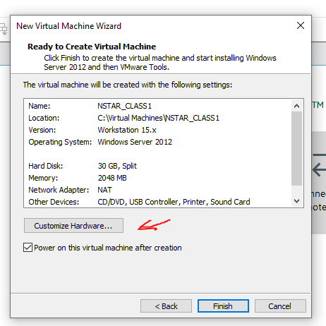

- Set desired memory for this virtual machine
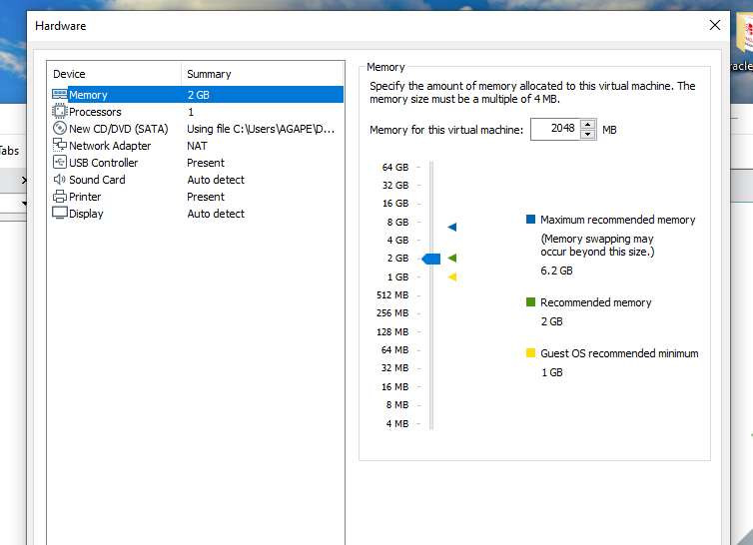
- Set Network Adapter to Bridged and click close and finish
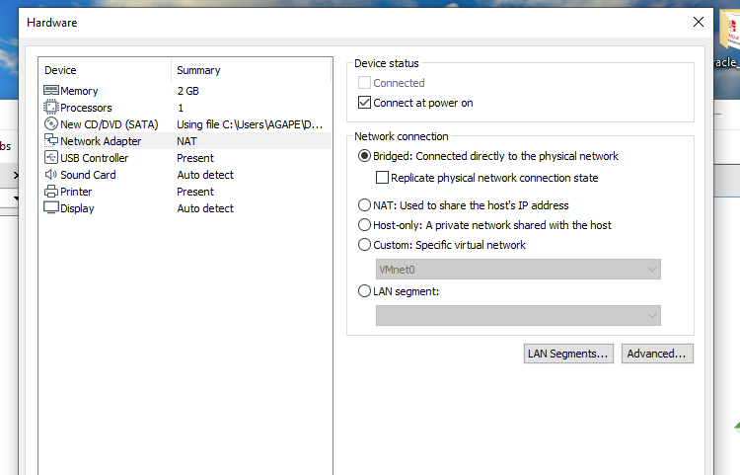
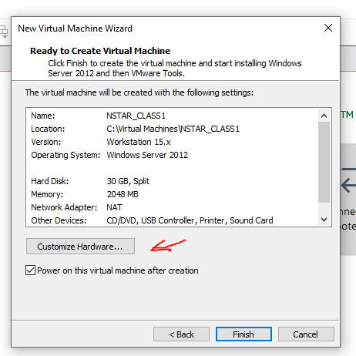
- Installation Screen
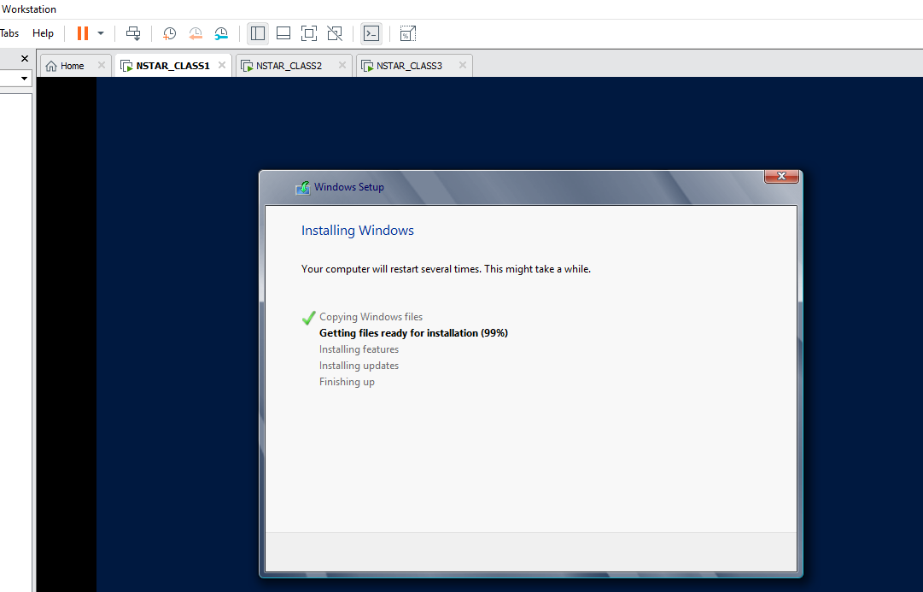

- Repeat steps for next Virtual machine creation
- Proof of completion
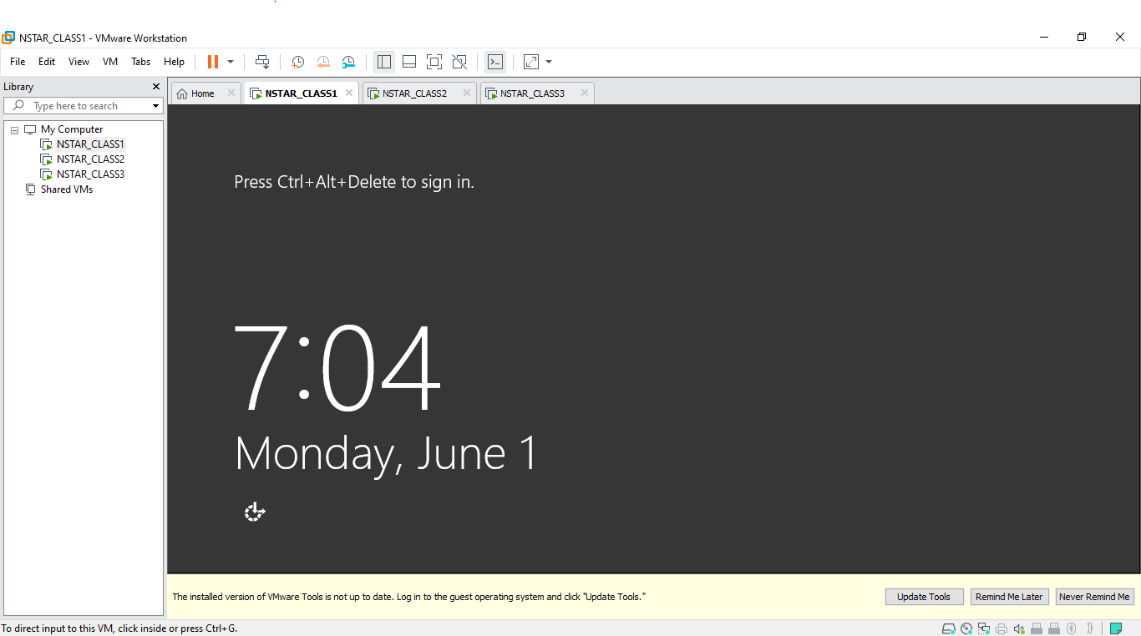

SIDE NOTES:
- If the VM presents a black screen instead of running the installation Upgrade the VM (Steps for upgrade listed below)
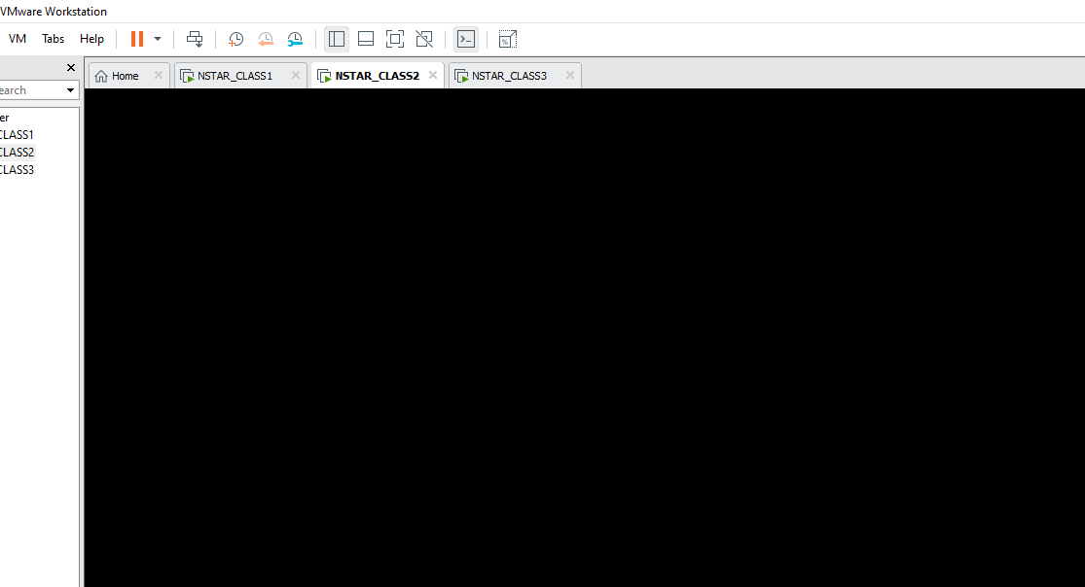

- During installation of a Virtual machine, if the VM presents two options choose GUI and click NEXT
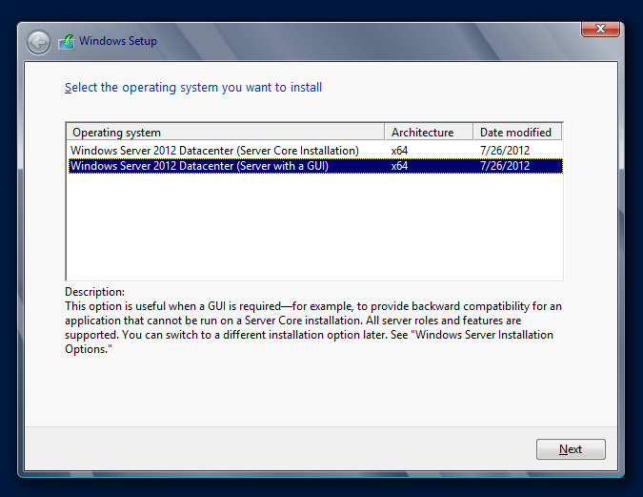
- RARE CASE: If the VM talks about using the wrong product key, then the wrong ISO file was selected

STEPS TO UPGARDE VM WARE
- Click help and select software updates, next click check for updates
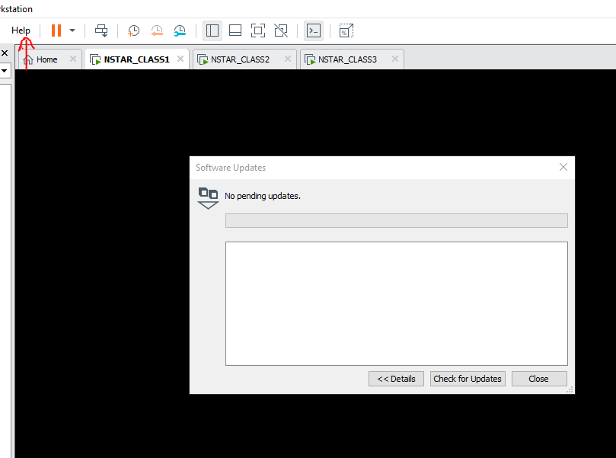

- Next click download and install
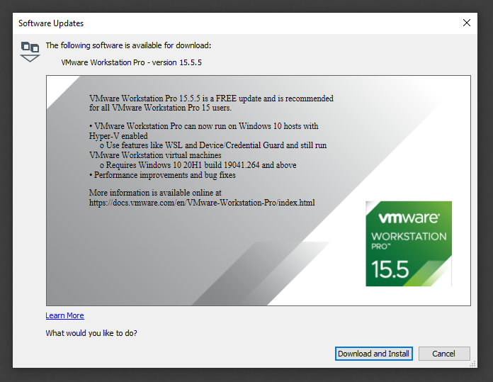
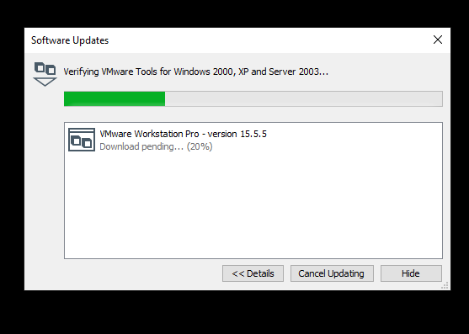
- Click YES to both prompts

- Click yes to restart, and return to rerun the installer
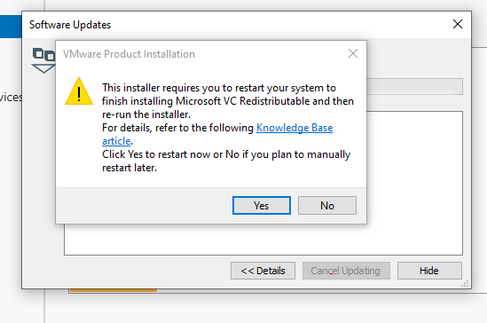
- After restart launch VM ware again
- Select Help and software updates again
- Click check for updates again
- Select Download and install again
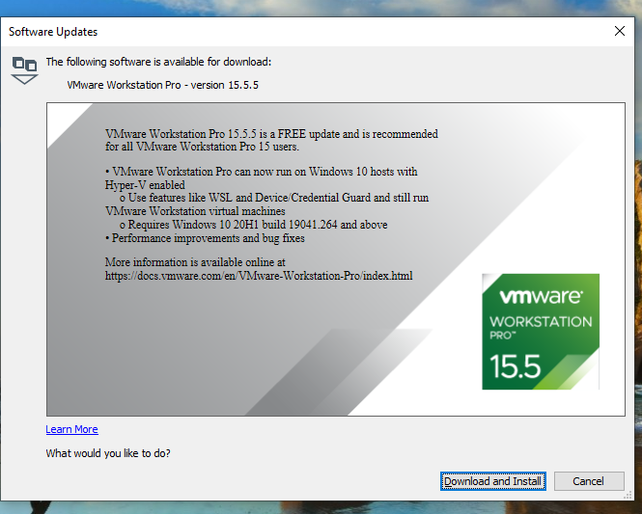
- Steps might look repeated but that’s okay
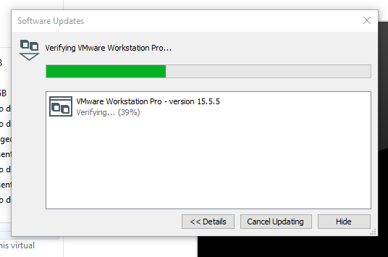
- You will need to close VM ware to continue
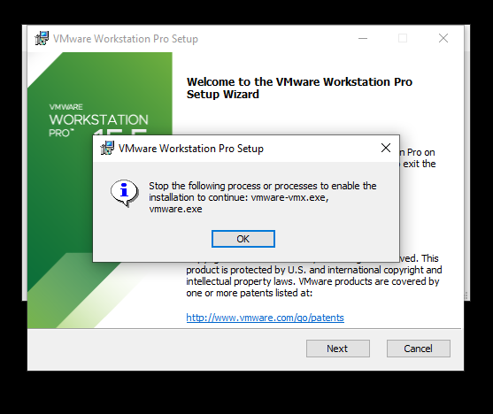

- Click I accept and Next
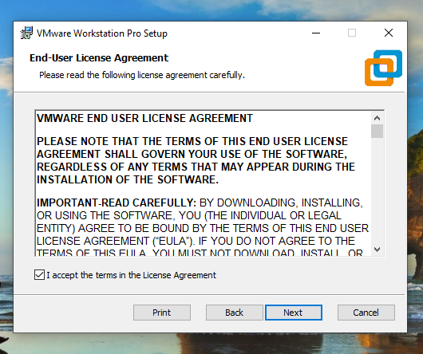
- Leave unchecked and click next
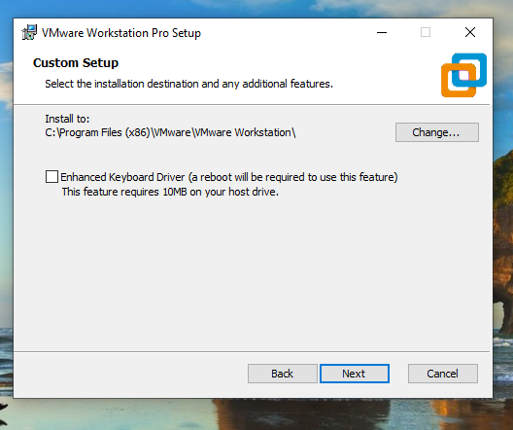

- Uncheck both and click next
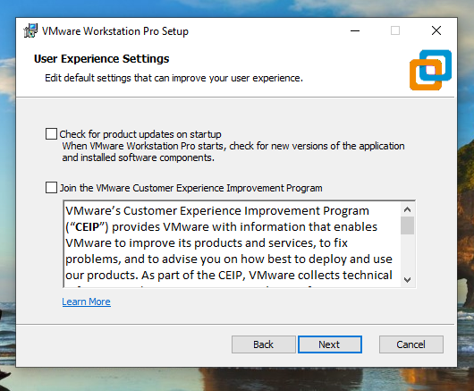

- And Next again
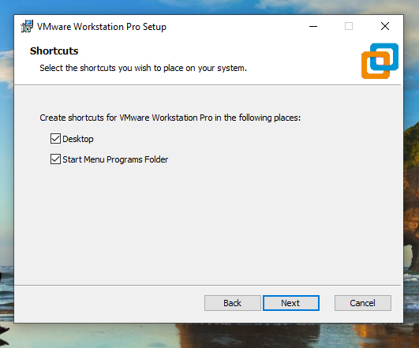
- Now Click upgrade
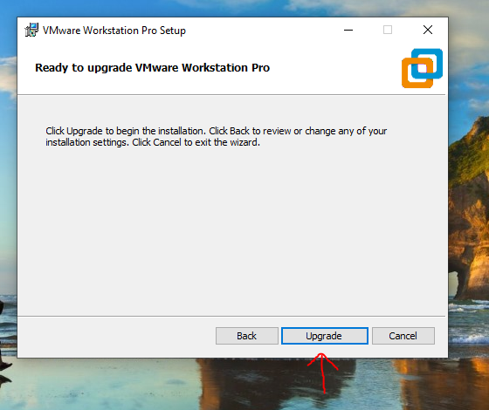
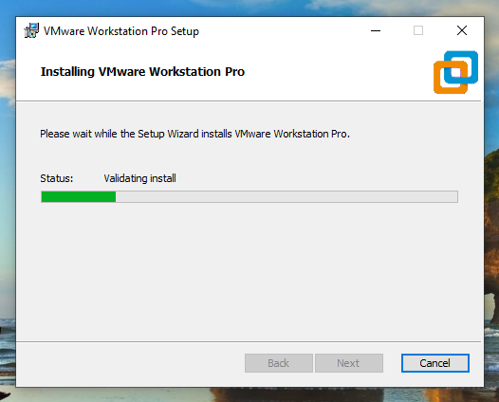

- Next select license
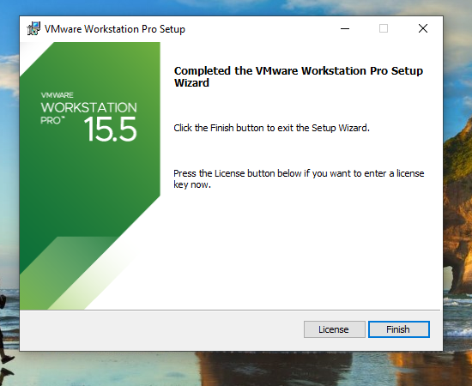
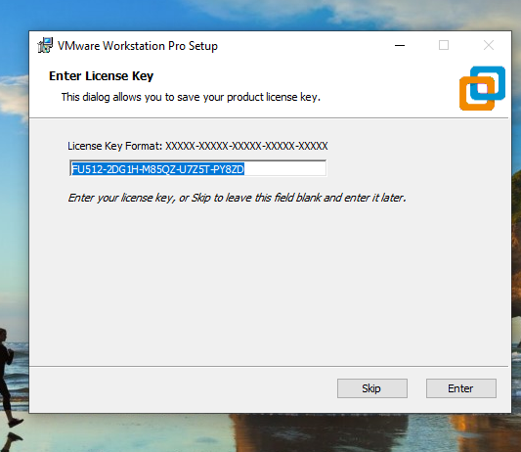

- Select Enter and finish
